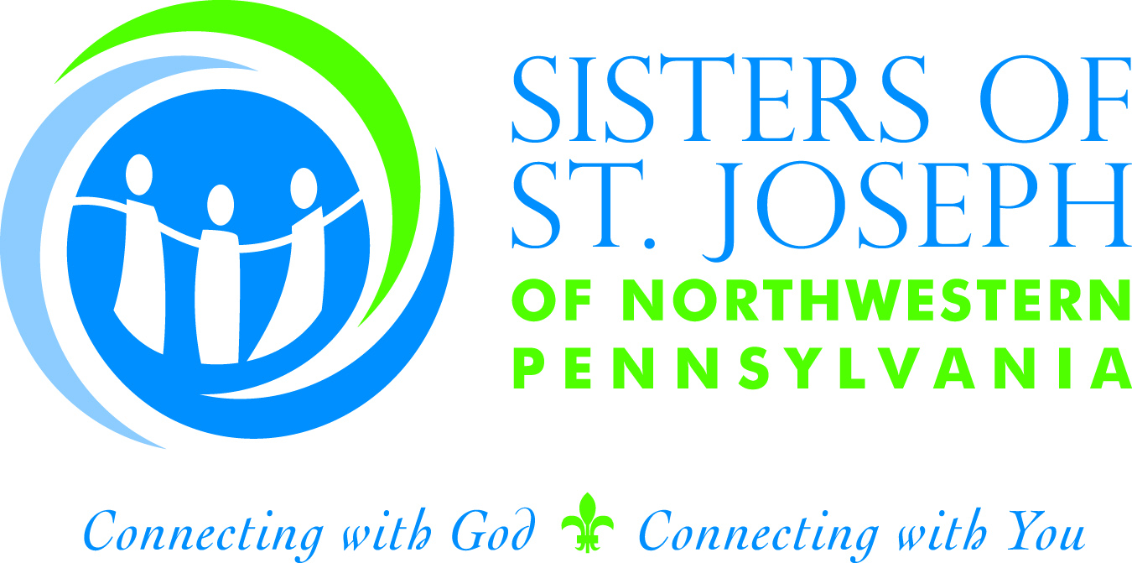
MEDIA RELEASE
For Immediate Release
31 July 2016

CONTACT: Stephanie Hall

Director of Public Relations
814/836-4203
prdir@ssjerie.org

SISTERS OF ST. JOSEPH WELCOME

14 NEW ASSOCIATES

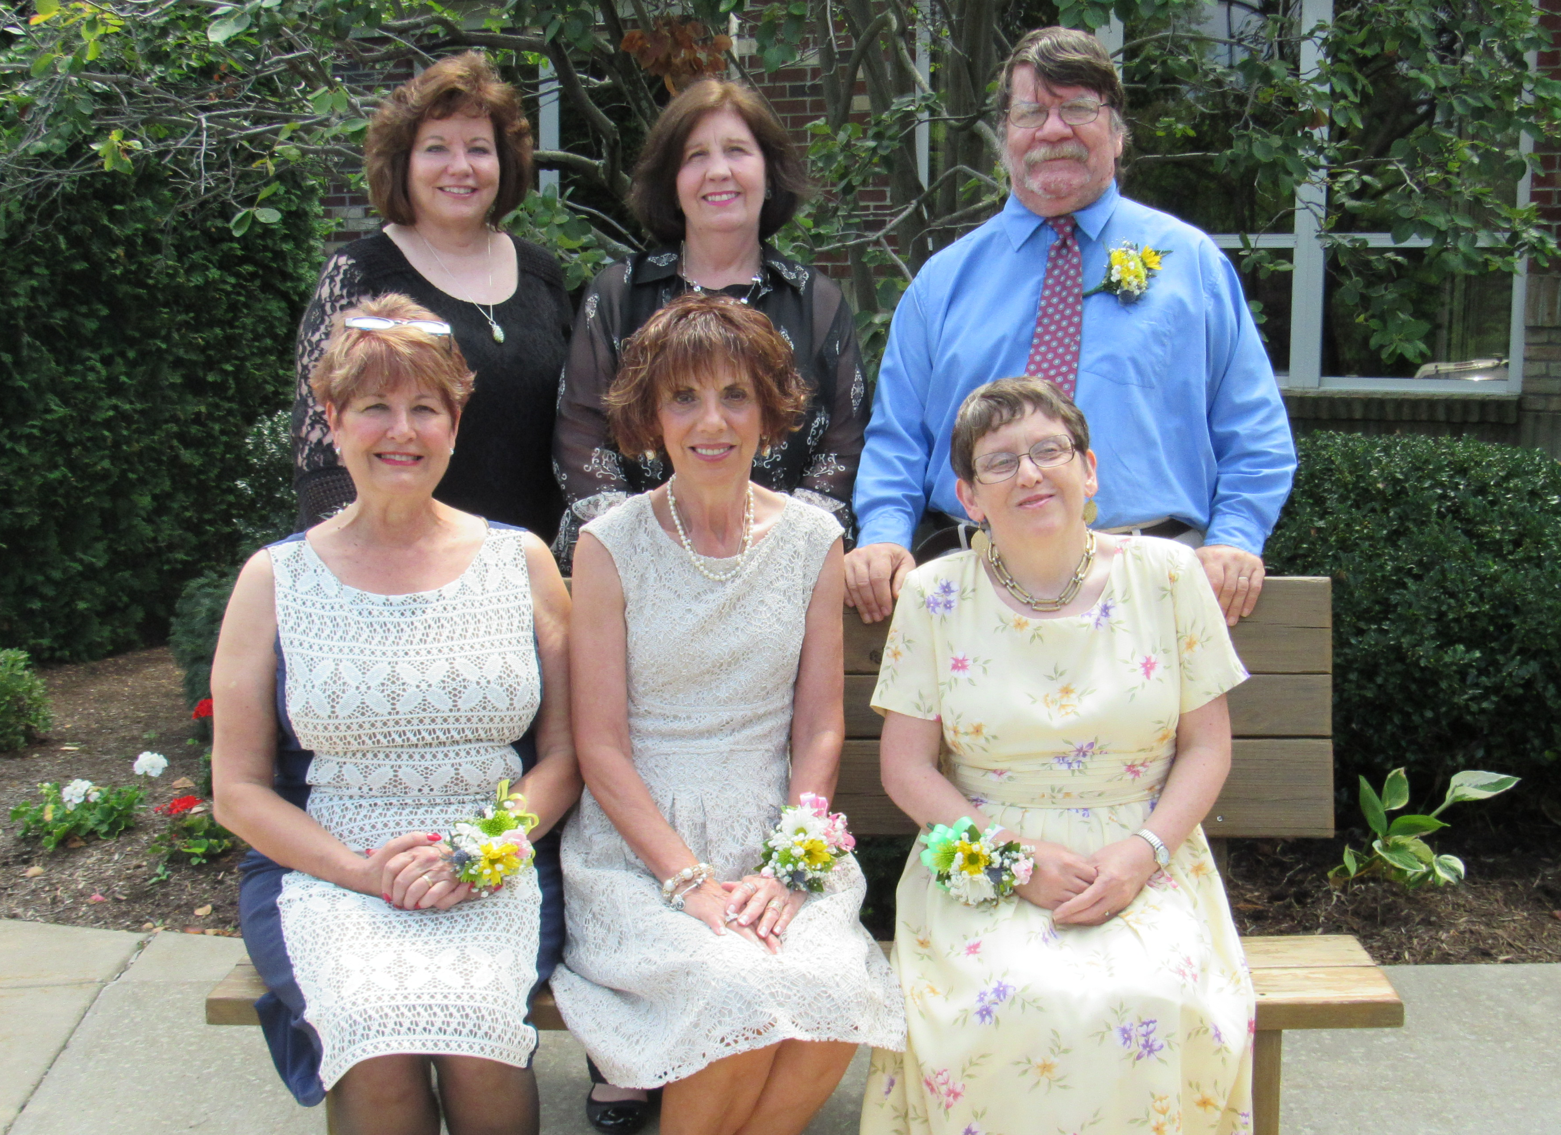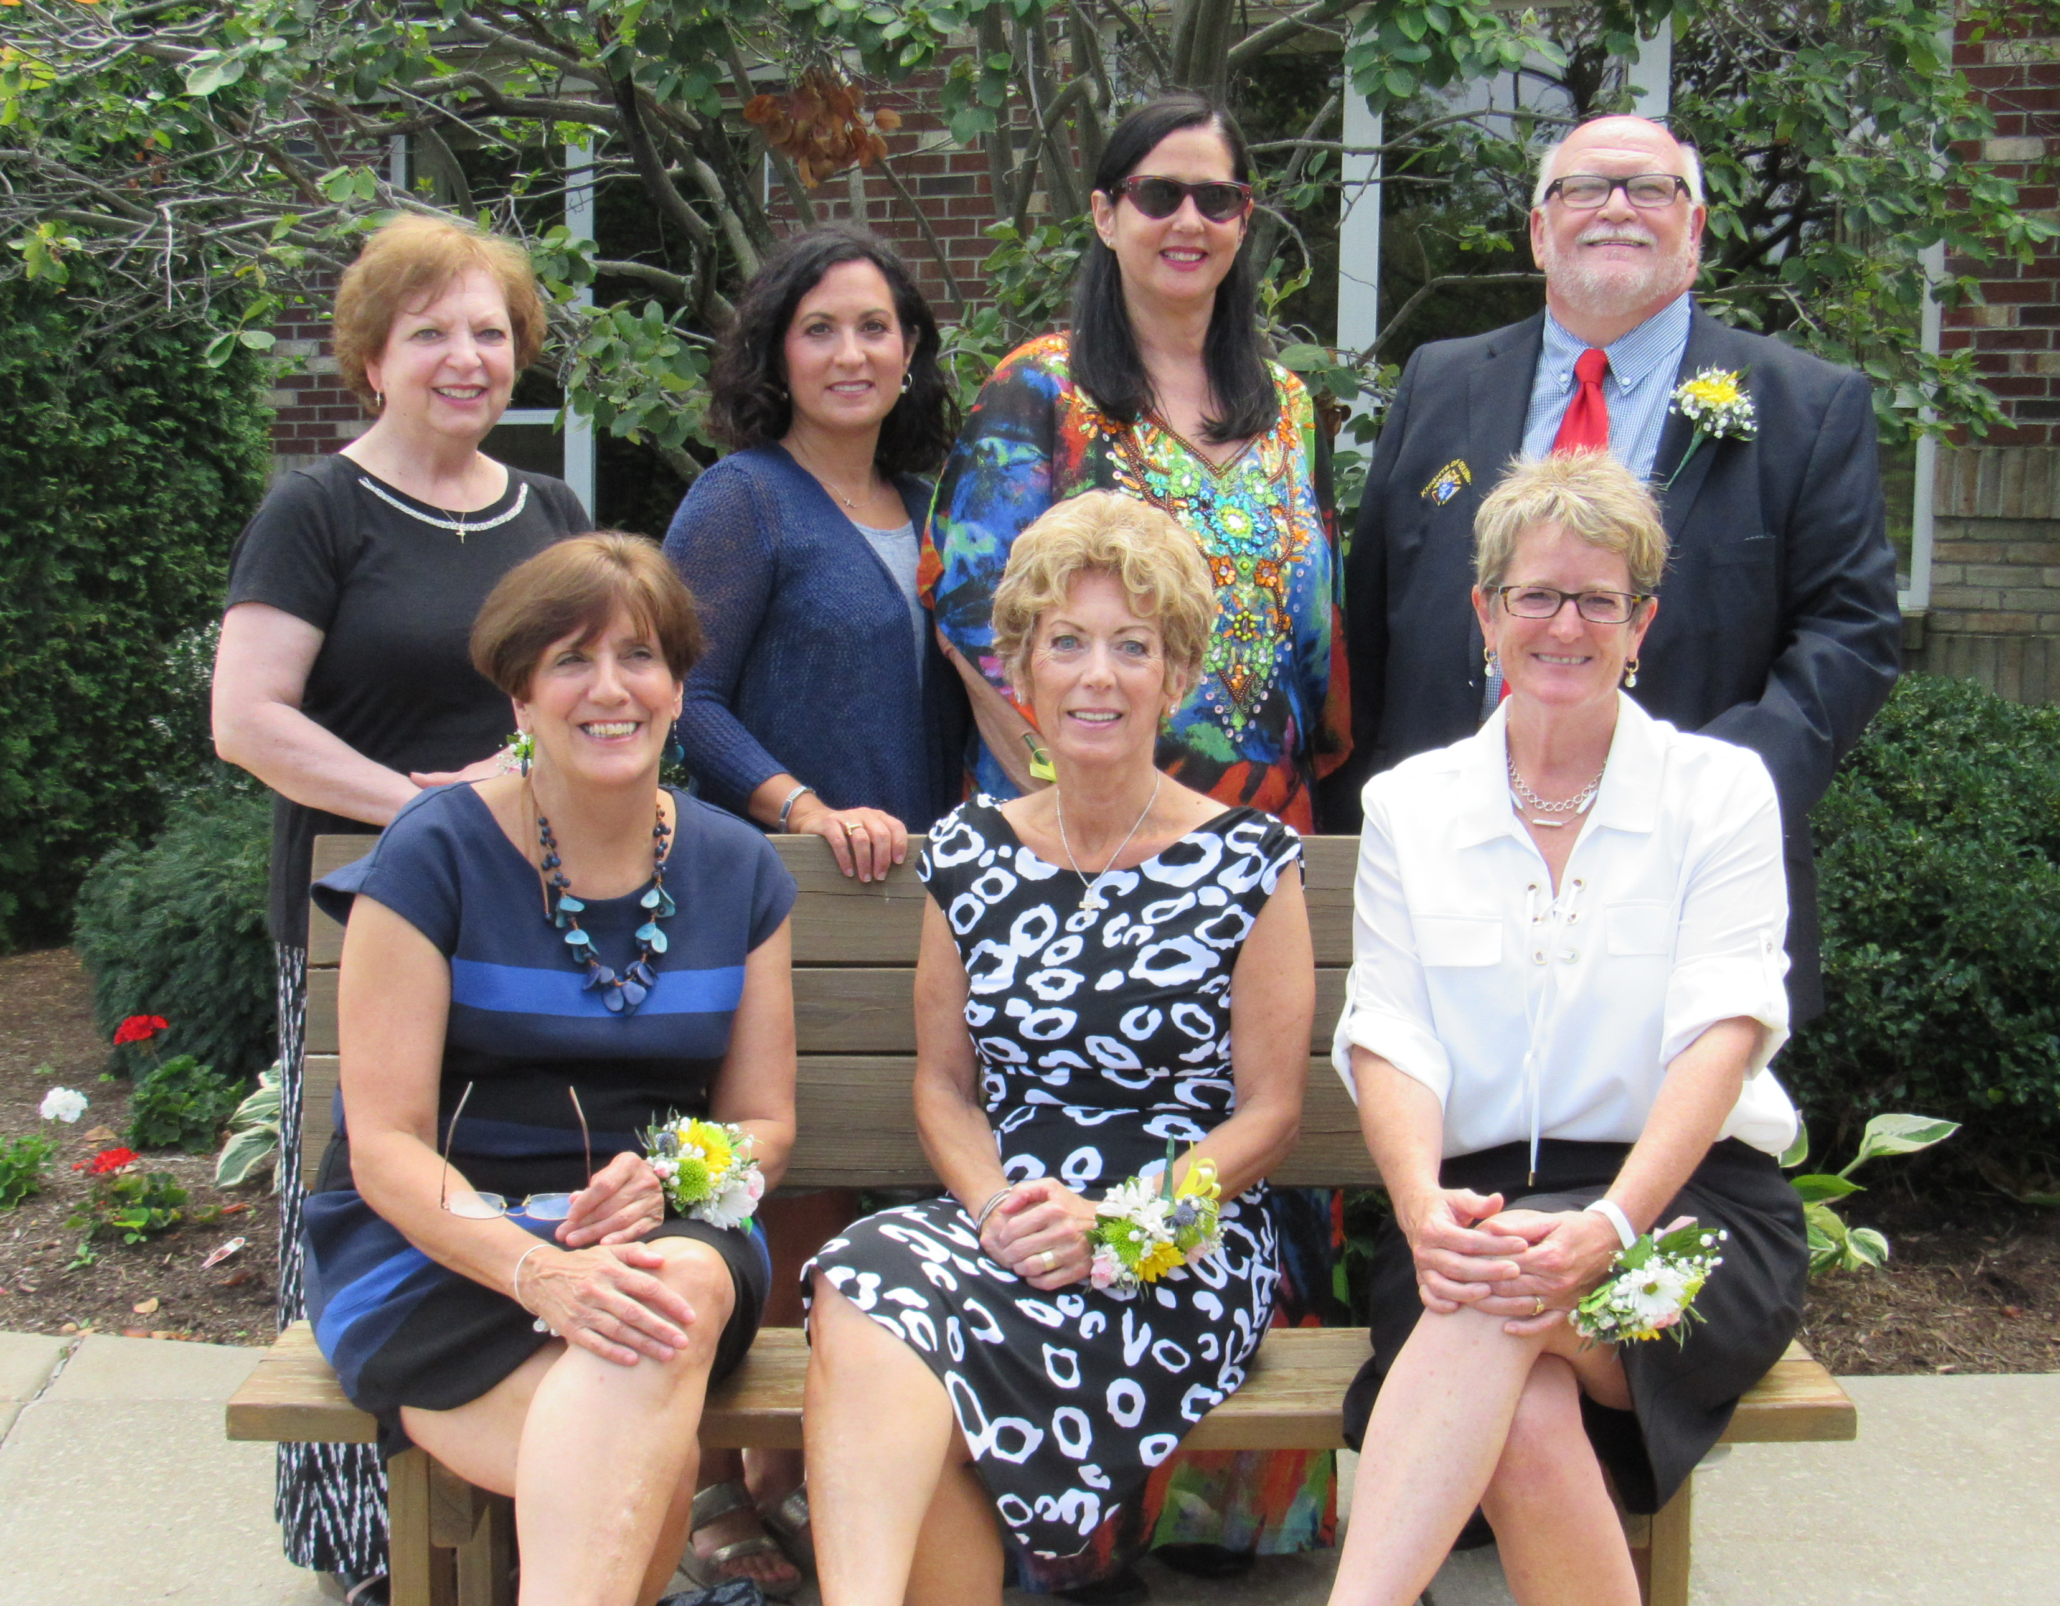
Left photo, (seated, l-r): Mary Schmidt, Margie Fischer, Francine Ballard. Standing (l-r): Mary Yochim, Sheila Causgrove, Karl Ballard. Right photo, seated (l-r): Joanne Sprickman, Sandra Filippi, Rose Graham. Standing (l-r): Connie Pellerite, Cindy Ferber, Barb Noonan, Lew Nordin, Sr. (Not pictured: Mary Ann Larimer)

The Sisters of St. Joseph of Northwestern Pennsylvania welcomed 14 new associates during a special liturgy held on July 31, 2016 in the chapel of the Sisters’ Community Living Center in Millcreek, PA. The new associates were received by Mary Herrmann, SSJ, Mary Ann White, SSJ, and Clare Marie Beichner, SSJ, Congregation Leadership; and Linda Kuhn, SSJA and Nancy Donnelly, SSJA, Co-Directors of the SSJ Associates. A reception followed the liturgy.
Associates welcomed into membership were: Karl and Francine Ballard, Sheila Causgrove, Cindy Ferber, Sandra Filippi, Marjorie Fischer, Rose Graham, Mary Ann Larimer, Barb Noonan, Lew Nordin, Sr., Connie Pellerite, Mary Schmidt, Joanne Sprickman and Mary Yochim.

-more-

SSJ NEW ASSOCIATES
Page 2

SSJ Associates are Christian women and men who choose to come together to share the nature and spirit of the Sisters of St. Joseph. Associate candidates are required to complete a year of preparation and instruction about the history, mission, spirit and spirituality of the sisters before they are welcomed into the program and make their commitment which is renewed annually.
“We are delighted to welcome 14 new associates this year. Associates are women and men of all ages and Christian traditions who share our gift of unity of neighbor with neighbor and neighbor with God, our prayer life, our ministries and our mission as much as they are able,” said Mary Ann White, SSJ, Leadership. “This partnership continues to evolve over the years into our common future as we deepen our relationship with our God and the neighbor.”
The practice of associate membership dates back to the founding of the Congregation in France in the seventeenth century.
Currently, there are more than 250 associates of the Sisters of St. Joseph of Northwestern Pennsylvania. For more information about SSJ Associates, call the SSJ Associate Office at 814-836-4134.

