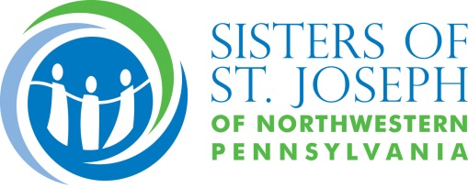

FOR RELEASE
October 4, 2016

Sisters of St. Joseph announce closing of
Villa Maria Elementary School in Erie

(Erie, PA) Sister Mary Herrmann, president of the Sisters of St. Joseph of Northwestern Pennsylvania, announced today that Villa Maria Elementary School, a longtime Catholic elementary school in Erie—will close at the end of the 2016-17 academic year. The school is a sponsored ministry of the Sisters of St. Joseph, not a diocesan school.

The announcement comes following thorough consideration and review of several factors, most notably the results of the Erie diocesan pastoral planning process which began in 2014 and included a review of Catholic education. Though not diocesan, Villa Maria Elementary participated in the process. Results of that study indicated that current demographics do not support keeping all the Erie area Catholic elementary schools open. The Sisters of St. Joseph, as a diocesan congregation, feel strongly about supporting Catholic education as outlined in the diocesan plan. “This is a proactive response that reflects our belief that together we are stronger and can more effectively fulfill the Gospel mandate of preaching and teaching God’s Word,” Herrmann said.

The VME faculty, staff, and parents were informed of the Sisters’ decision at special meetings held on Monday. Villa Maria Elementary School currently has 271 students enrolled in grades K-8, all of whom can be accommodated in the new Erie Catholic School System. The early announcement will give families an opportunity to attend Catholic school open houses this winter.

-more-

“The VME family is proudly made up of loyal, dedicated, and supportive families as well as a hardworking, talented, and committed faculty and staff,” said Damon Finazzo, Villa Maria Elementary principal. “Together, we will process this sad news and continue our commitment to our beloved students. We will be making special efforts to help everyone transition and move forward in a positive manner.”

The Sisters of St. Joseph have demonstrated a commitment to Catholic education for 156 years. The congregation founded Villa Maria Elementary, Villa Maria Academy, Villa Maria College and staffed numerous diocesan schools.

“Guided by our mission to constantly respond to the ever-changing needs of the world, we continually review our lives and ministries and make changes when indicated,” Herrmann said. “We let go of sponsored institutions and ministry priorities of the past when we realized the needs no longer existed, or were being met by others. This has allowed us to keep responding to the needs of the day.”

“One of the things I admire most about women religious is their commitment to following wherever the Spirit leads them,” said Bishop Lawrence T. Persico. “When they see a need, they meet it. In our diocese, they have addressed needs in healthcare, in Catholic education and in social ministry, always filling the gaps. But they also have the courage to move on when those needs are met by others.”

###

